| **Computing Fundamentals & Programming**  ***Section*: BSCE2021 Assignment # 11 *Total marks*: 100**  ***Name*** : ***Muhammad Abubakar Saif Roll number* : BSCE21017** |
| --- |

***Submission:***

• *Email instructor or TA if there are any questions. You cannot look at others’ solution or use others’ solution, however, you can discuss it with each other. Plagiarism will lead to a straight zero with additional consequences as well.*

*• Submission after due time will not be accepted.*

**TASKS:**

**Q1** Write a program that does the following, report your output and also explain it:

**i)** declare an integer x and y

Give both of them values in the range of 0 to 19

Check if x is less than 20

If true Add the value of x into y and display the new value

**Solution:**



After running the above code, the new value displayed is **25**.

**Explanation:**

In line 1, two variables x and y are declared and assigned values 7 and 18 respectively.

In line 2, there is a condition which checks whether x is smaller than 20, if this condition is true then the program will go inside it.

In line 3, it will add the value of x into y.

In line 4, the new value of y is displayed on Console.

In line 5, there is bracket indicating the end of if condition working

**ii)** declare an integer x and y

Give both of them values in the range of 0 to 19

Check if x is less than 20

If true Add the value of x into y and display the new value

Else subtract the value of x from y and display the new value



After running the above code, the new value displayed is **25**.

**Explanation:**

In line 1, two variables x and y are declared and assigned values 7 and 18 respectively.

In line 2, there is a condition which checks whether x is smaller than 20, if this condition is true then the program will go inside it else program will run statements written under **ELSE** command.

In line 3, it will add the value of x into y.

In line 4, the new value of y is displayed on Console.

In line 5, the **ELSE** scope begins.

In line 6, it will subtract the value of x from y.

In line 7, the new value of y is printed on the console.

In line 8, there is bracket indicating the end of if condition working

**iii)** In your code in part i) place a semicolon ( ; ) after the if condition.

**iv)** In your code in part ii) place a semicolon ( ; ) after the if condition.

**v)** Print a reverse sequence of 50 numbers starting from i = 100 in a while loop.

e.g 100, 96, 92, 88 …...



**vi)** In your code in part v) place a semicolon ( ; ) after the loop condition.

**vii)** int x = 1;

while(x <= 10)

{

int x =0;

x++;

cout<< x;

}

What errors do you get from this code? How many times do you have to run this loop?



**vii)**

int b = 200;

b = b * 10;

{

int x =0;

x++;

cout<< x;

}

cout<<x;

What errors do you get from this code? What output do you get? Explain.



**Q2**  i. Declare a variable x giving it an initial value of 1.

ii. Print 10 consecutive numbers starting from x

iii. Double x

iv. Repeat from 2. A total of 5 times.

**Solution:**

**Q3** Write a program that outputs the factorial of the first 10 numbers starting from 1



**Output:**

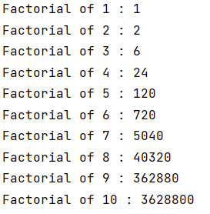

**Q4** Write a program that takes number input into an int array of size 3. Your program should square these numbers and output them.

You are to repeat the process with fresh values for your array till the user enters -111.



**Output:**

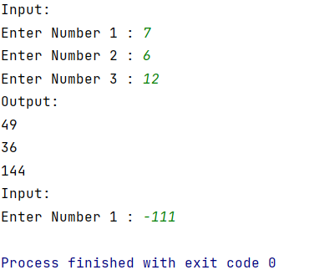

**Q5** Print a multiplication table as follows

1 2 3 4 5 6

2 4 6 8 10 12

3 6 9 12 15 18

4 8 12 16 20 24

Again the number of columns and rows is taken from the user.

In this example the column size entered is 6 and the number of rows is 4.



Output:

